PROJECT

SNOWFLAKE AND POWER-BI

HEALTHCARE APPOINTMENT NO-SHOW ANALYTICS USING SNOWFLAKE

PROJECT REPORT

DOCUMENTATION BY
CHANDAN CHHAGAN

TABLE OF CONTENTS

Sr. No. | Contents
1 | Introduction
2 | Problem Statement
2.1 | Objective
2.2 | Abstract of the Project
2.3 | Dataset Used
3 | Implementation
3.1 | Work Overview
3.2 | Project Flow
3.3 | Data Transformation Process
4 | Reports and Dashboard
5 | Conclusion

1. INTRODUCTION

The purpose of this project is to develop a Healthcare Appointment No-Show Analytics System using Snowflake. The project focuses on analyzing patient appointment data to identify attendance patterns, no-show behavior, waiting times, and the impact of SMS reminders on appointment attendance.

The system uses Snowflake for data storage, transformation, and processing. Data is loaded from CSV files into Snowflake, transformed using Snowpark Python, and analyzed through reporting views. Finally, Power BI is connected to Snowflake to create interactive dashboards that help healthcare organizations make better decisions and improve patient appointment management.

2. PROBLEM STATEMENT

Hospitals and healthcare organizations often face challenges when patients miss scheduled appointments. No-show appointments lead to wasted resources, reduced efficiency, and increased operational costs.
The organization wants to analyze appointment data to understand patient behavior, identify high-risk no-show groups, evaluate the effectiveness of SMS reminders, and generate meaningful reports for decision-making. A scalable data pipeline is required to automate data loading, transformation, and reporting.

2.1 OBJECTIVE
The main objectives of this project are:
- To build a complete healthcare analytics solution using Snowflake.
- To load appointment data from CSV files into Snowflake.
- To transform raw healthcare data using Snowpark Python.
- To implement Change Data Capture (CDC) using Streams.
- To automate data ingestion using Snowpipe.
- To create reporting views for Power BI.
- To analyze patient attendance and no-show patterns.
- To generate dashboards for business insights.

2.2 ABSTRACT OF THE PROJECT
This project implements an end-to-end Healthcare Appointment No-Show Analytics solution using Snowflake Cloud Data Platform.
The appointment dataset is uploaded into a Snowflake Internal Stage and loaded into a raw table using the COPY INTO command. Snowpark Python Stored Procedures are used to clean and transform the raw data into a structured final table.
Snowflake Streams are implemented to capture newly inserted records and support incremental data loading. Snowpipe is configured to automate future data ingestion from staged files.
A reporting view is created for Power BI integration, enabling users to visualize healthcare appointment trends through interactive dashboards. The solution provides insights into appointment attendance, missed appointments, waiting times, age-group behavior, and SMS reminder effectiveness.

2.3 DATASET USED
The project uses the Medical Appointment No-Show Dataset available from a public source.
The dataset contains the following information:
- Patient ID
- Appointment ID
- Gender
- Scheduled Date
- Appointment Date
- Age
- Neighborhood
- Scholarship Status
- Hypertension
- Diabetes
- Alcoholism
- Handicap
- SMS Received
- No-Show Status
This dataset is used to analyze patient appointment attendance and identify factors contributing to missed appointments.

3. IMPLEMENTATION

3.1 WORK OVERVIEW
The project follows a structured Snowflake data engineering workflow:
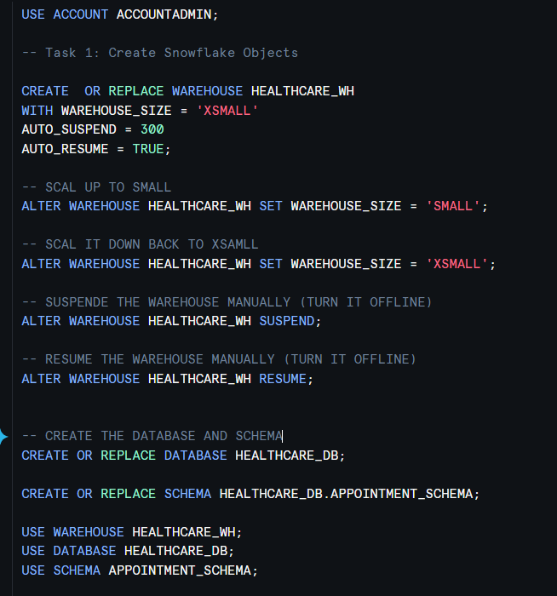
- Create Snowflake Warehouse, Database, and Schema.

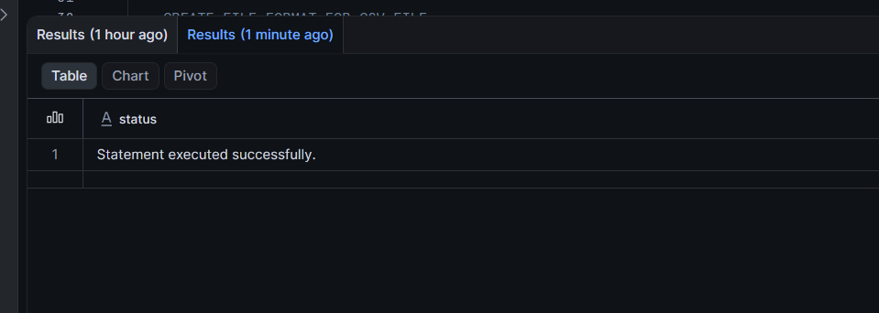

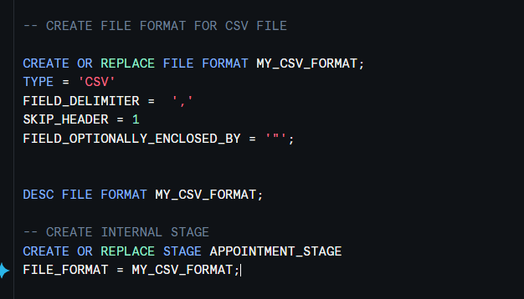
- Create File Format and Internal Stage.
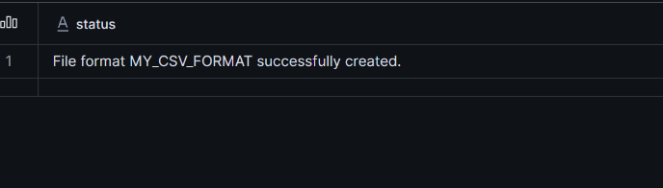

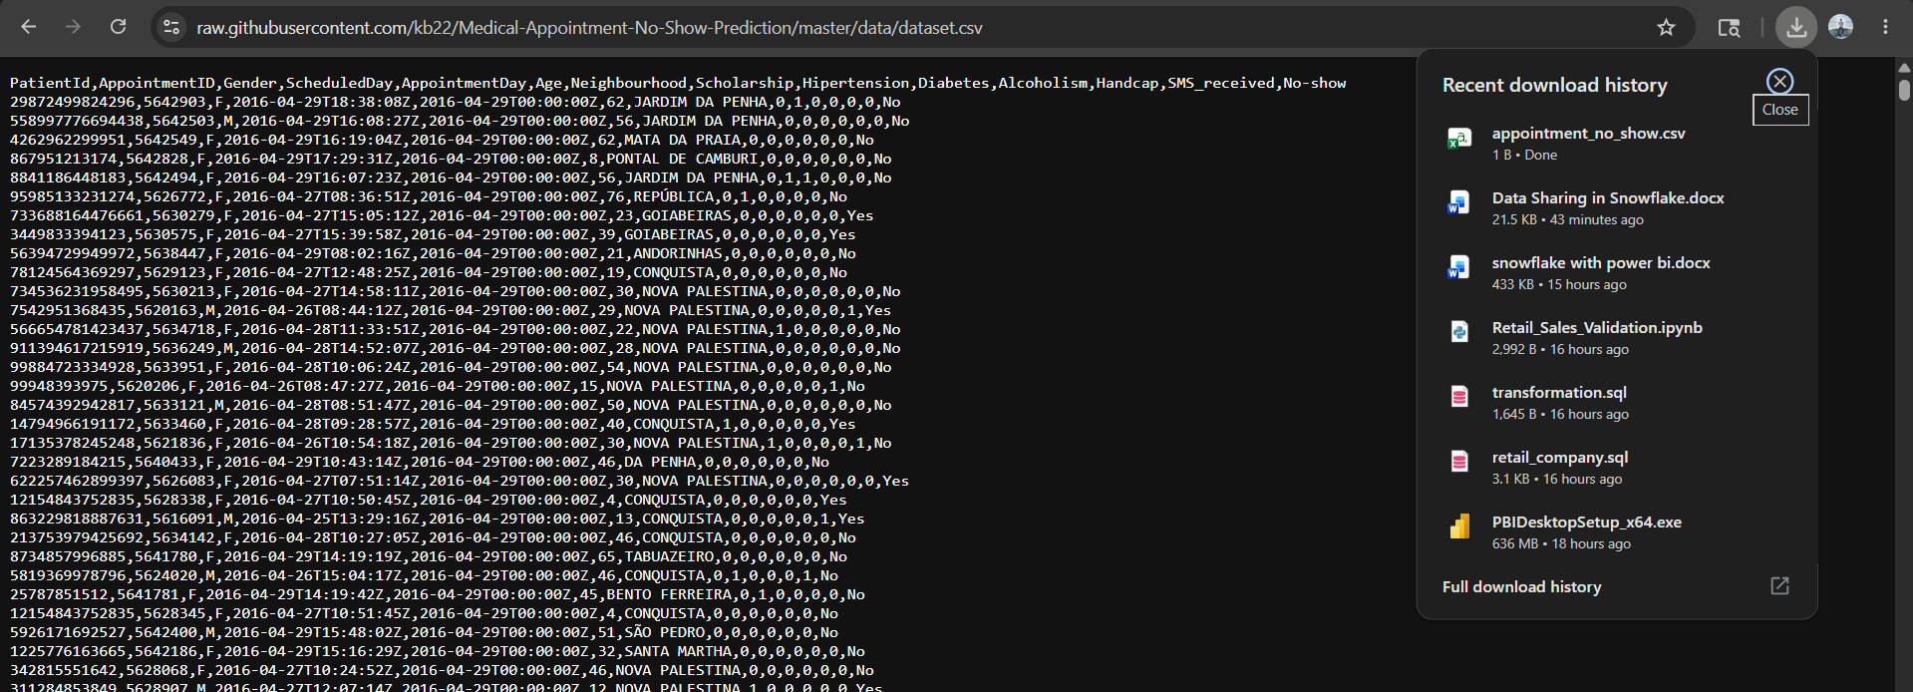
- Download the healthcare appointment dataset.

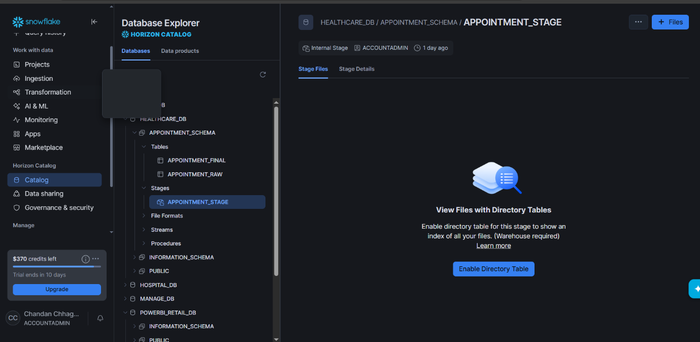
- Upload the CSV file into the Snowflake Internal Stage.

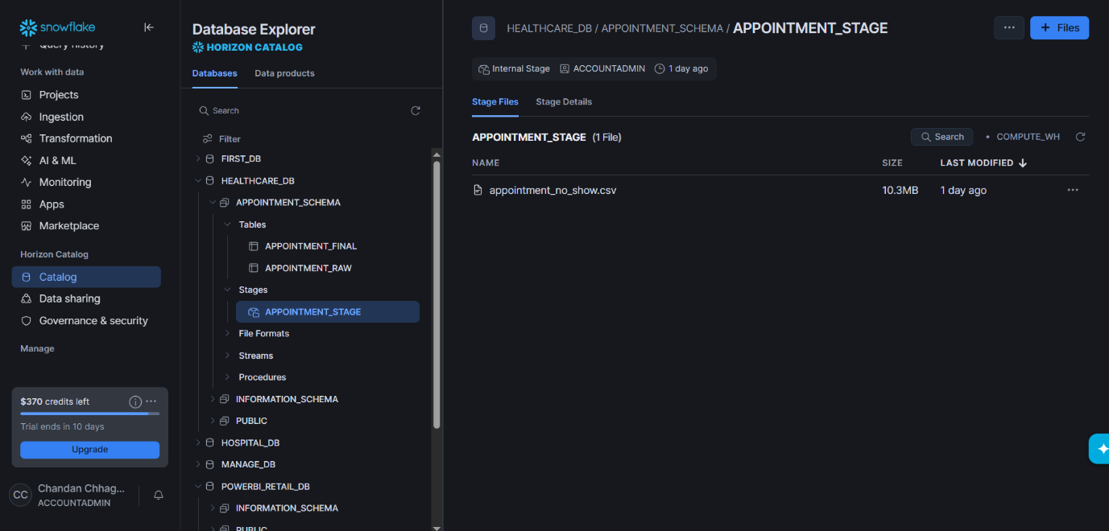
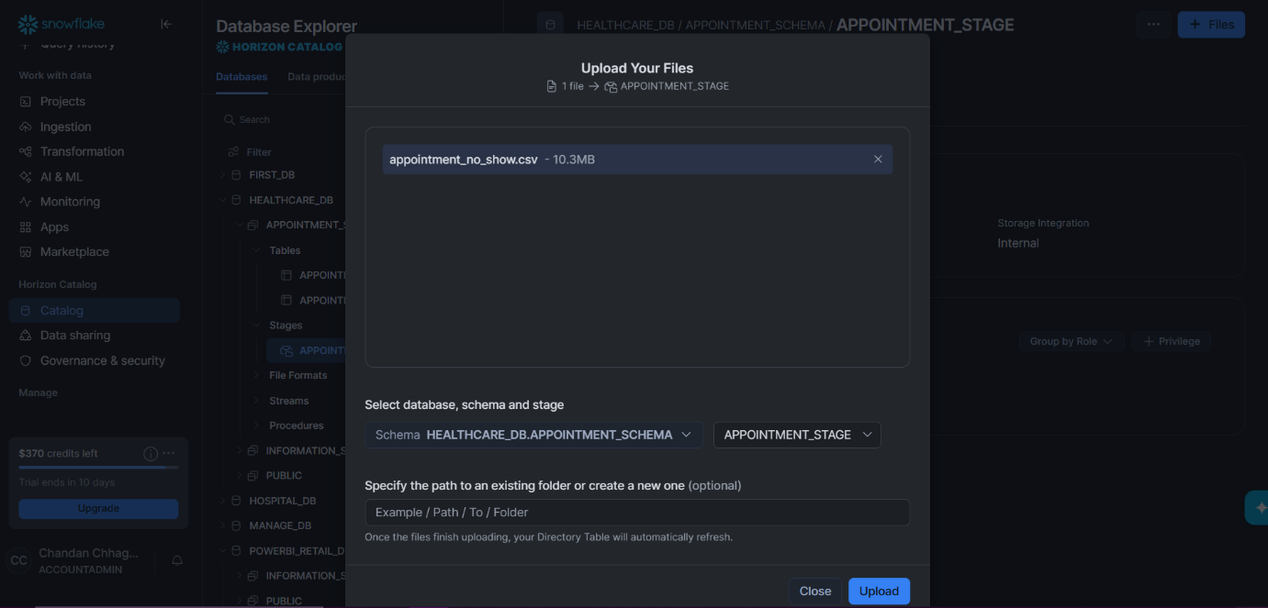

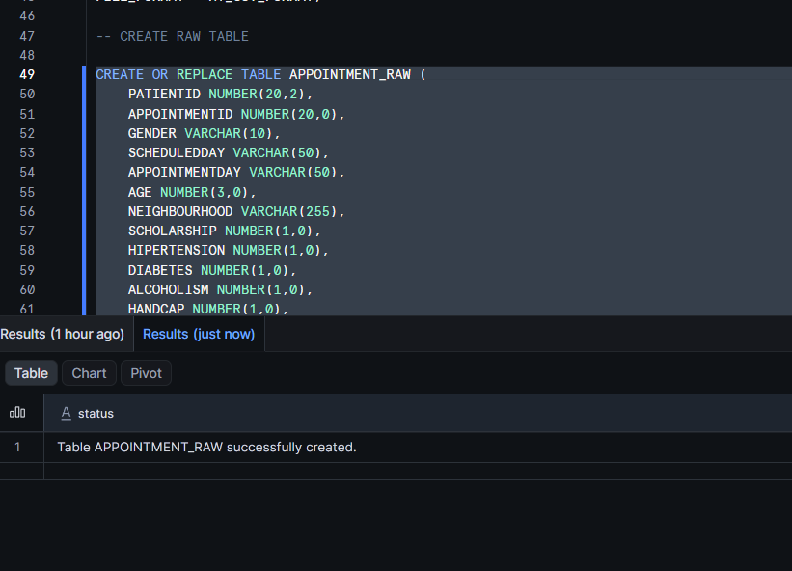
- Create Raw and Final Tables.
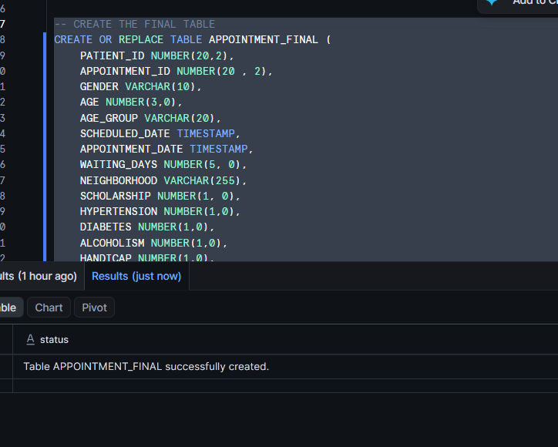

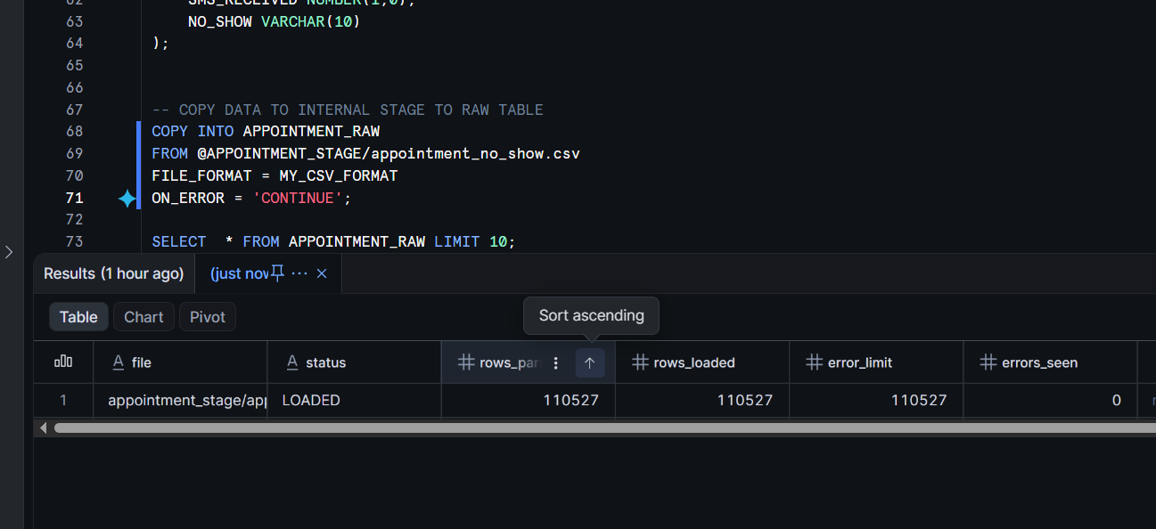
- Load data using COPY INTO.

- Transform data using Snowpark Python.
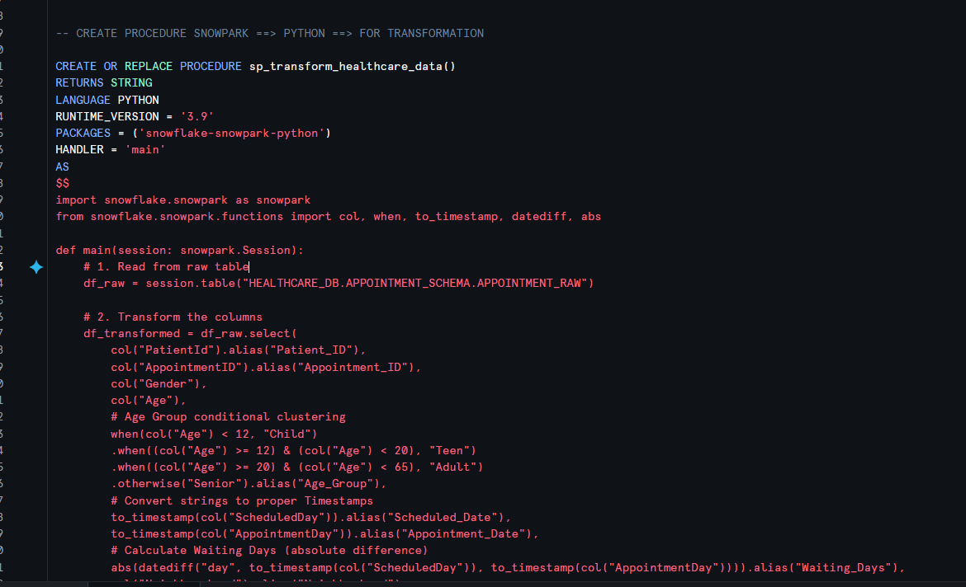

-- AS WE KNOW SNOWPARK CODE NOT WORK IN STANDARD ACCOUNT SO I WRITE SQL CODE FOR TRANSFORMATION
INSERT INTO HEALTHCARE_DB.APPOINTMENT_SCHEMA.APPOINTMENT_FINAL
(
PATIENT_ID,
APPOINTMENT_ID,
GENDER,
AGE,
AGE_GROUP,
SCHEDULED_DATE,
APPOINTMENT_DATE,
WAITING_DAYS,
NEIGHBORHOOD,
SCHOLARSHIP,
HYPERTENSION,
DIABETES,
ALCOHOLISM,
HANDICAP,
SMS_RECEIVED,
NO_SHOW_STATUS,
ATTENDANCE_STATUS
)
SELECT
PATIENTID AS PATIENT_ID,
APPOINTMENTID AS APPOINTMENT_ID,
GENDER,
AGE,

CASE
WHEN AGE < 12 THEN 'Child'
WHEN AGE >= 12 AND AGE < 20 THEN 'Teen'
WHEN AGE >= 20 AND AGE < 65 THEN 'Adult'
ELSE 'Senior'
END AS AGE_GROUP,

TO_TIMESTAMP(SCHEDULEDDAY) AS SCHEDULED_DATE,
TO_TIMESTAMP(APPOINTMENTDAY) AS APPOINTMENT_DATE,

ABS(
DATEDIFF(
DAY,
TO_TIMESTAMP(SCHEDULEDDAY),
TO_TIMESTAMP(APPOINTMENTDAY)
)
) AS WAITING_DAYS,

NEIGHBOURHOOD AS NEIGHBORHOOD,
SCHOLARSHIP,
HIPERTENSION AS HYPERTENSION,
DIABETES,
ALCOHOLISM,
HANDCAP AS HANDICAP,
SMS_RECEIVED,
NO_SHOW AS NO_SHOW_STATUS,

CASE
WHEN NO_SHOW = 'Yes' THEN 'Missed'
ELSE 'Visited'
END AS ATTENDANCE_STATUS

FROM HEALTHCARE_DB.APPOINTMENT_SCHEMA.APPOINTMENT_RAW;

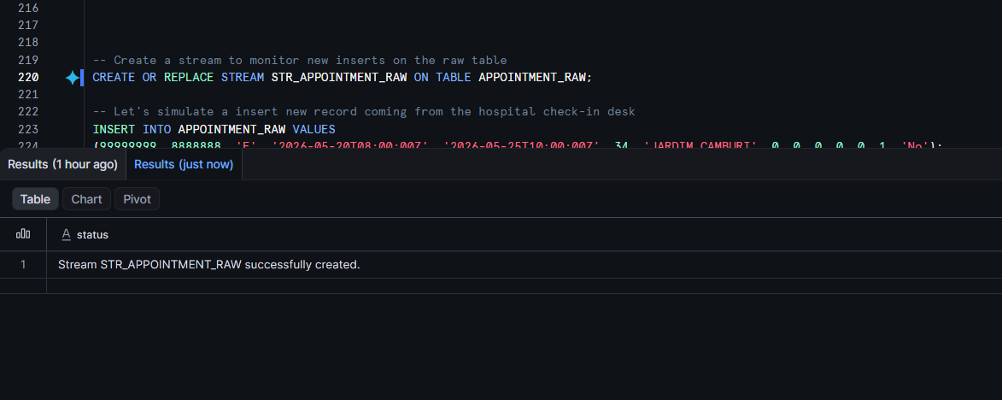
- Create Streams for Change Data Capture.

- Perform Incremental Data Loading.

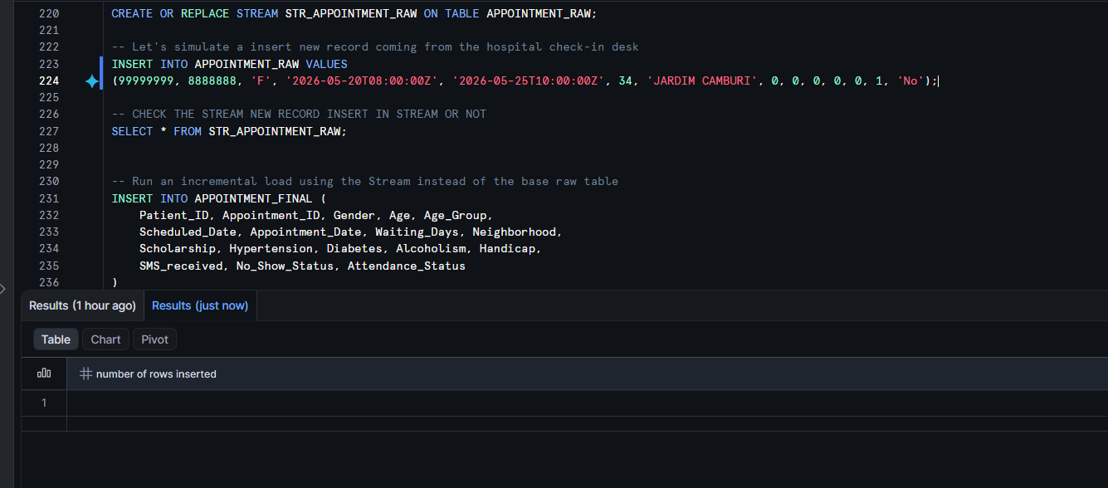
- FIRST INSERT NEW RECORD

- AS WE CAN SEE NEW RECORD THE AVAILABLE IN STREAM
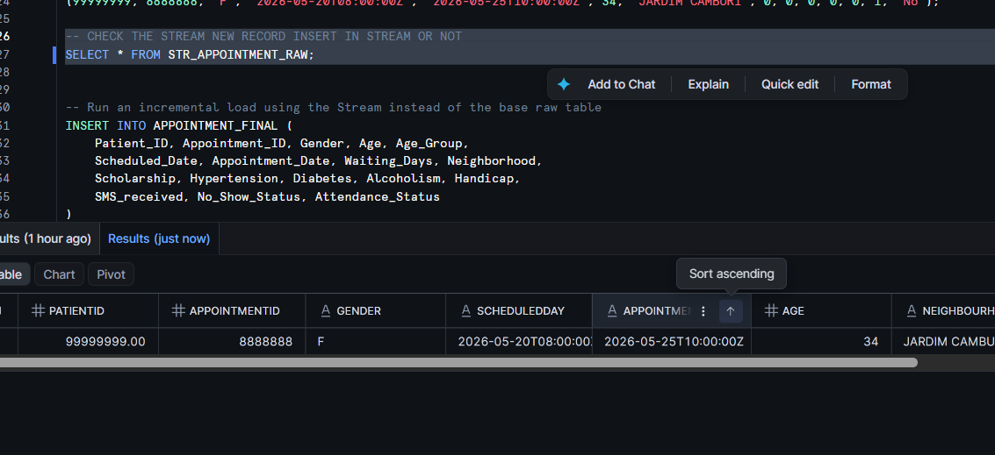

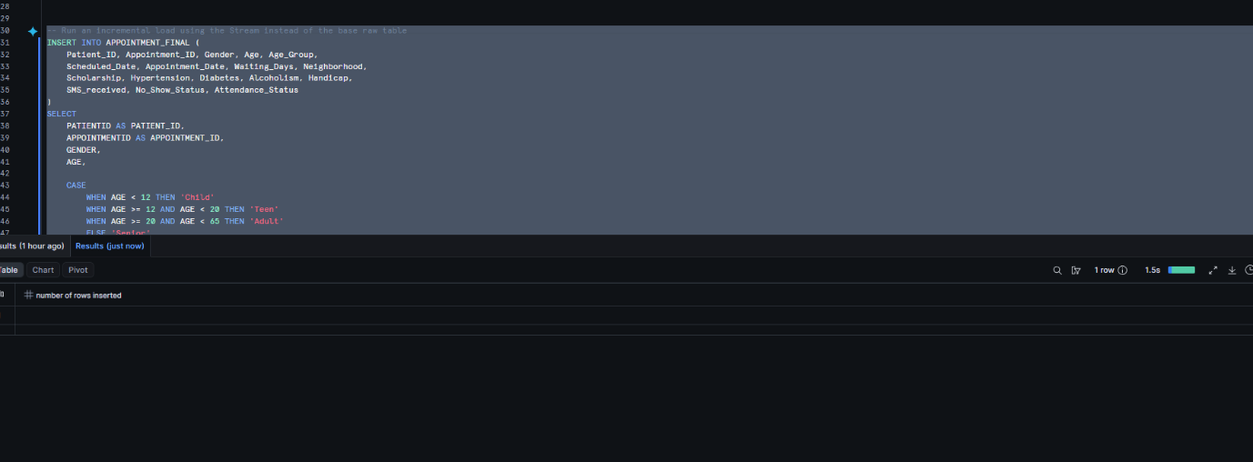
- AND LAST WE INSERT THE NEW RECORD IN THE FINAL TABLE

- Configure Snow pipe for automated ingestion.
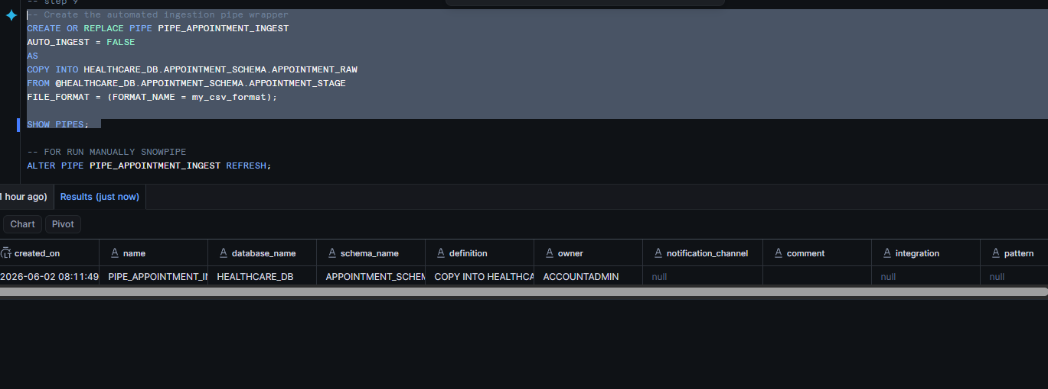

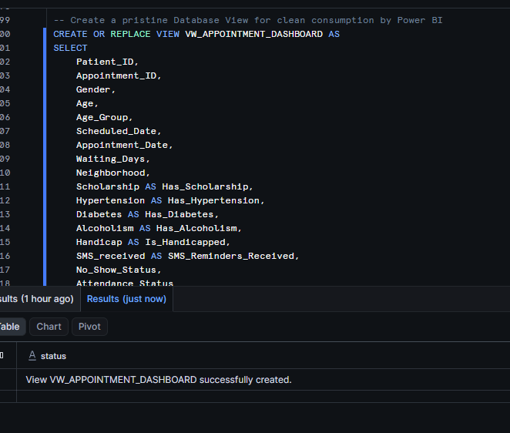
- Create Reporting Views.

- Connect Snowflake with Power BI.
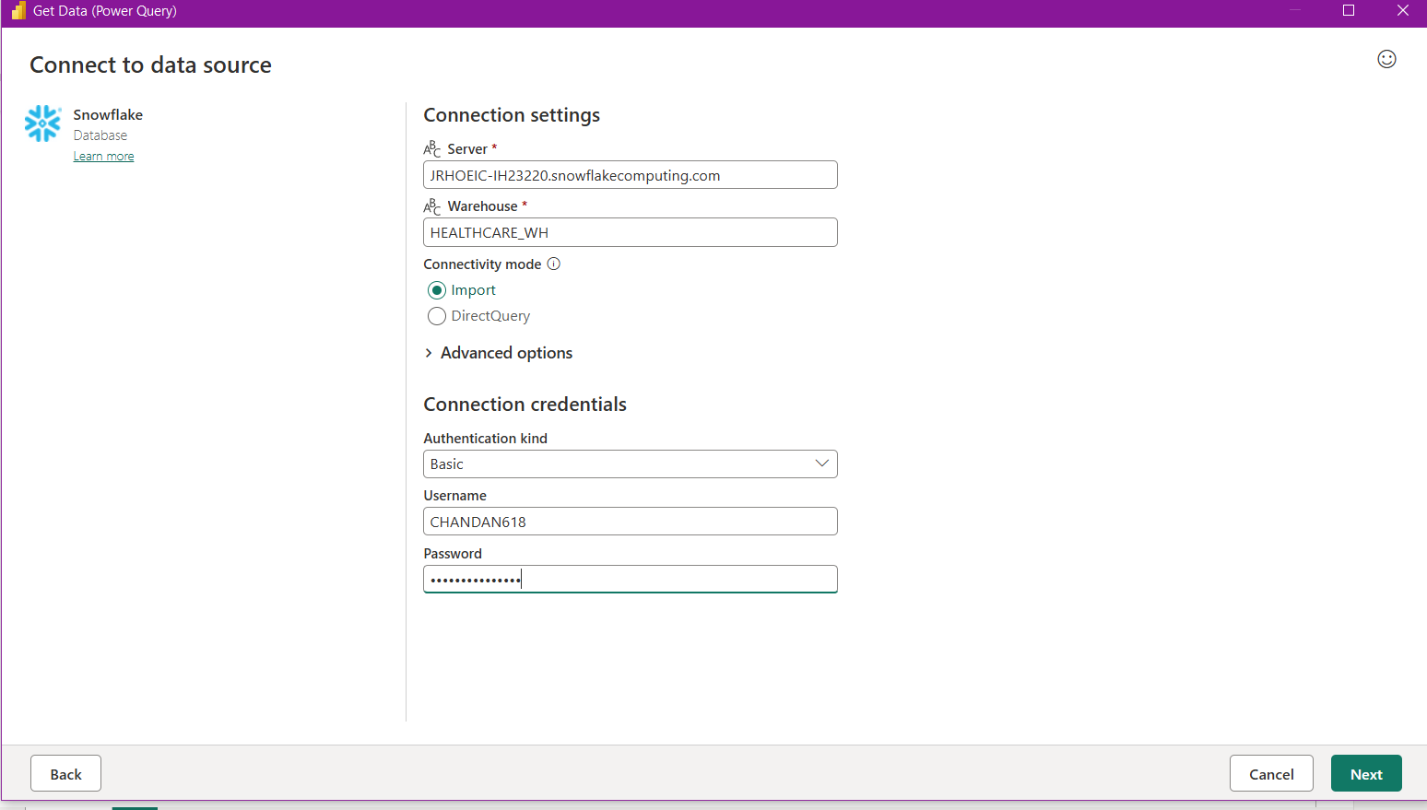

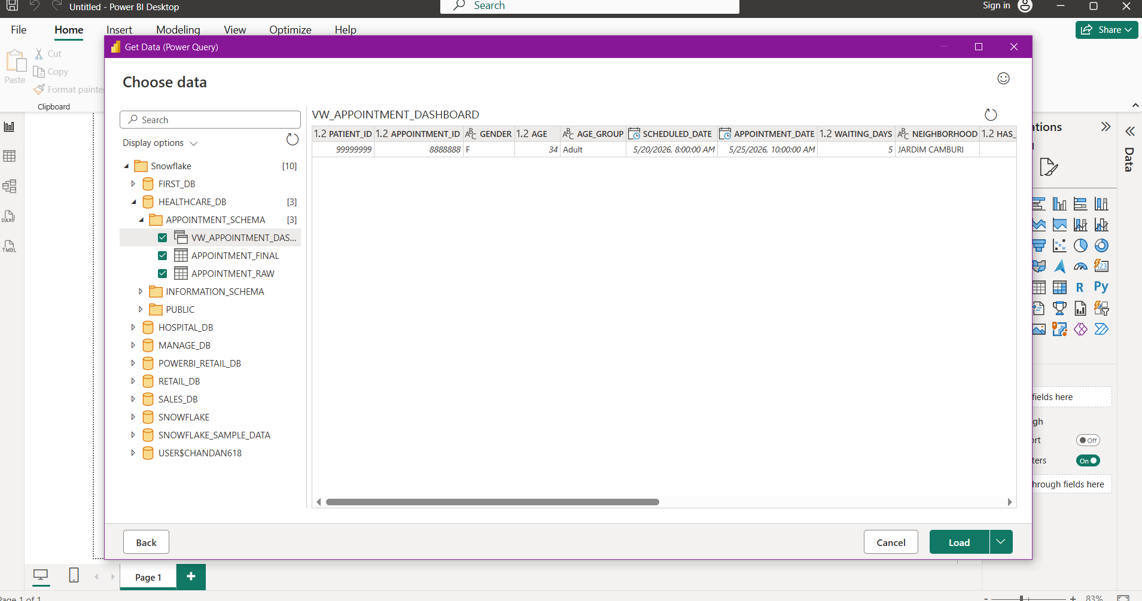

- Build analytical dashboards and reports.
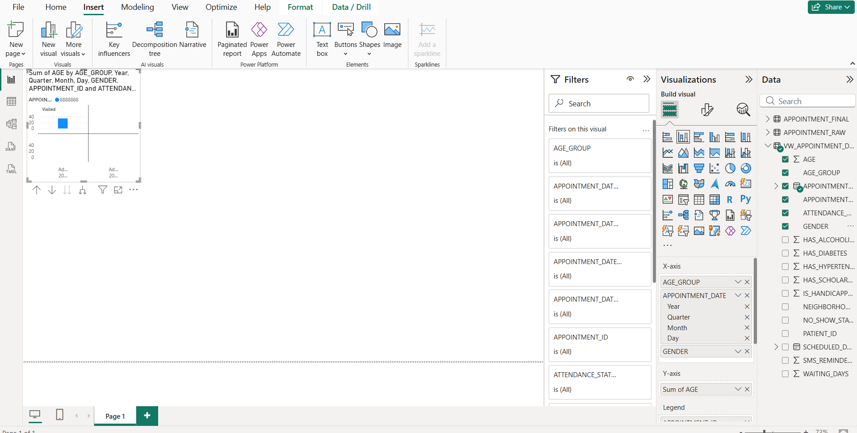

3.2 PROJECT FLOW
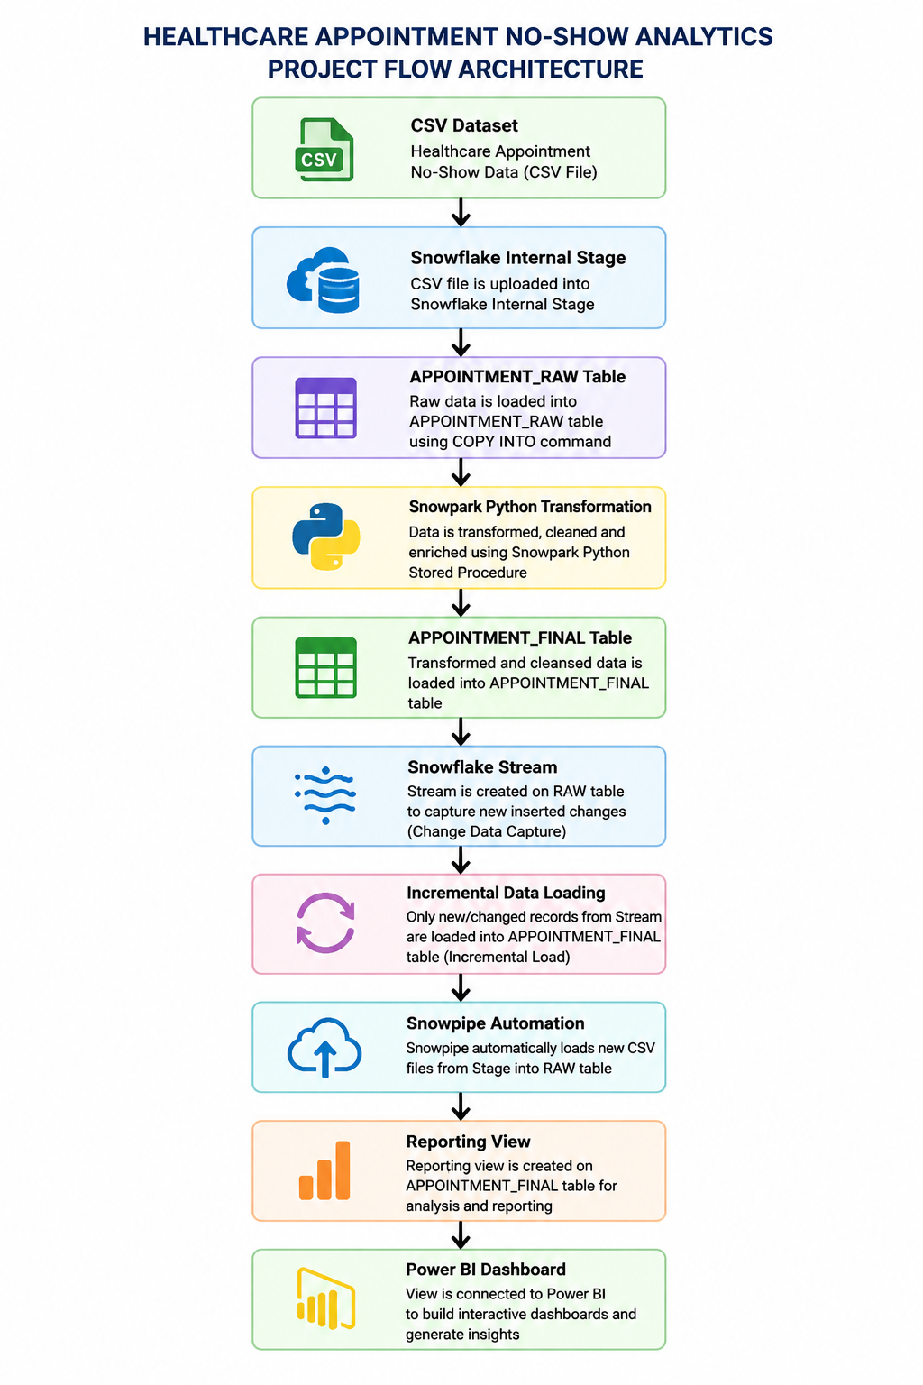

3.3 DATA TRANSFORMATION PROCESS

Data transformation is performed using Snowpark Python within Snowflake.
The following transformations are applied:
Data Reading
- Read data from APPOINTMENT_RAW table.
- Load data into Snowpark DataFrame.
Data Transformation
- Create Age Group categories.
- Convert date columns into timestamp format.
- Calculate Waiting Days.
- Rename columns for reporting.
- Generate Attendance Status.
Incremental Processing
- Capture new records using Snowflake Streams.
- Load only newly inserted records into the final table.
Automated Loading
- Use Snowpipe to automate future file ingestion.
Reporting Layer
- Create reporting views for dashboard development.

4. REPORTS AND DASHBOARD

The final dashboard is developed using Power BI and connected directly to Snowflake.

The dashboard contains the following reports:
Total Appointments
Displays the total number of appointments booked.
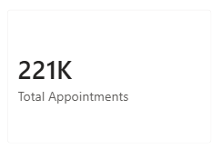

Missed Appointments
Displays the total number of patients who missed their appointments.

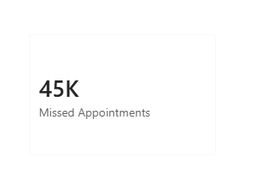
Visited Appointments
Displays the total number of patients who attended their appointments.
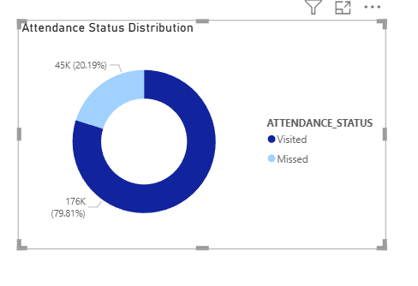
No-Show Rate
Displays the percentage of missed appointments.

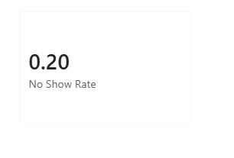
Average Waiting Days
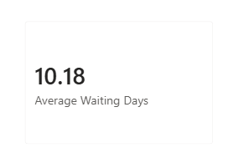
Shows the average waiting period between scheduling and appointment dates.

Attendance Status Distribution
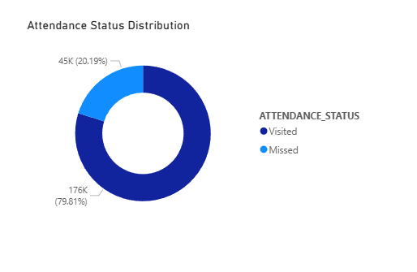
Displays appointment attendance using a donut chart.

No-Show by Age Group
Shows which age groups have the highest no-show rates.
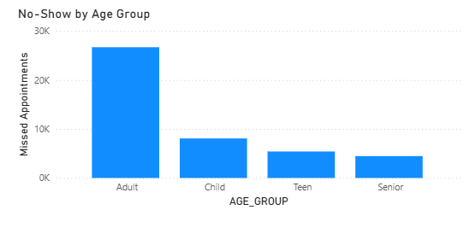

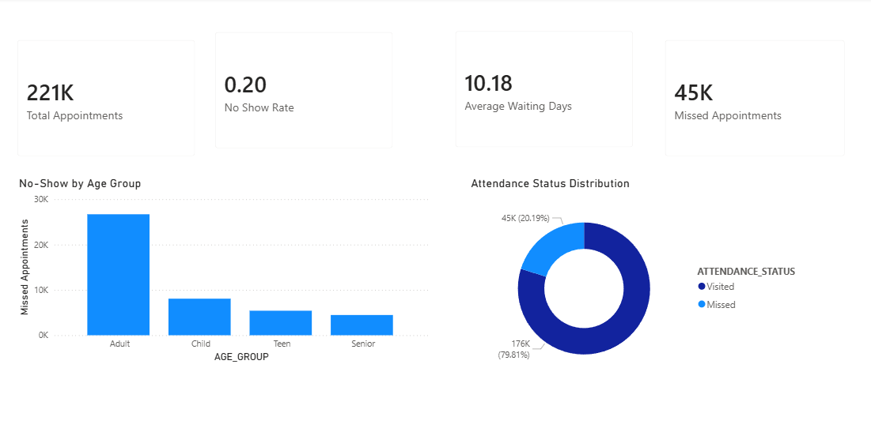
FINAL DASHBOARD:

5. CONCLUSION

This project successfully demonstrates the implementation of a Healthcare Appointment No-Show Analytics solution using Snowflake. The system automates data ingestion, transformation, change tracking, and reporting using modern cloud data engineering techniques.

By utilizing Snowpark Python, Streams, Snowpipe, and Power BI, the project provides valuable insights into patient attendance behavior and healthcare operational efficiency. The solution is scalable, automated, and suitable for real-world healthcare analytics applications. It helps healthcare organizations improve appointment management, reduce no-show rates, and enhance overall service quality.

